Computer Vision Research Notes
Article
Distortion Classification in Computer Vision Applications: Current Progress, Challenges, and Perspectives
Notes
Abstract
Sources of distortion: data acquisition, processing, compression, transmission, and storage (1).
Focus: methods related to CV and image processing, distortion detection and classification; application, techniques, databases (1).
Finding: ML -> Promising results for single distortion; challenging for multiple distortion classification. Missing distortions.
Introduction
Definitions related to distortion
- In-capture distortion: defocus blur, motion blur, noise, uneven illumination, and colour distortion (2).
- Implicit distortions: sub-sampling, signal quantization noise, and blocking and ringing artefacts (2).
- Adversarial distortions -> intended to deceive AI models -> misidentification or missing obejects (4)
- Distortion classification process: (i) determining the presence of distortion, (ii) identifying the the type of distortion and (iii) assessing its severity level on a graded scale, such as “hardly noticeable”, “just noticeable but not annoying,” “perceptually annoying,” or “very annoying.” (2)
Domains of distortion identification
- Visual Content Quality Assessment Framework: High level task, involving identification of the types of distortion. A widely used dataset: TID2013 (4). Image/Video Quality Assessment: Detect distortion, then evaluate (5).
- Medical Imaging (5, 6)
- Surveillance Applications and Security (6)
- Underwater Imaging (6): Sources of distortion-> diffraction, polarisation, light absorption, scattering, colour deterioration, and light attenuation. No known attempt to classification of underwater distortion automatically. Known work on classifications of underwater images and quality enhancement.
Types of Distortion
(Page 10)
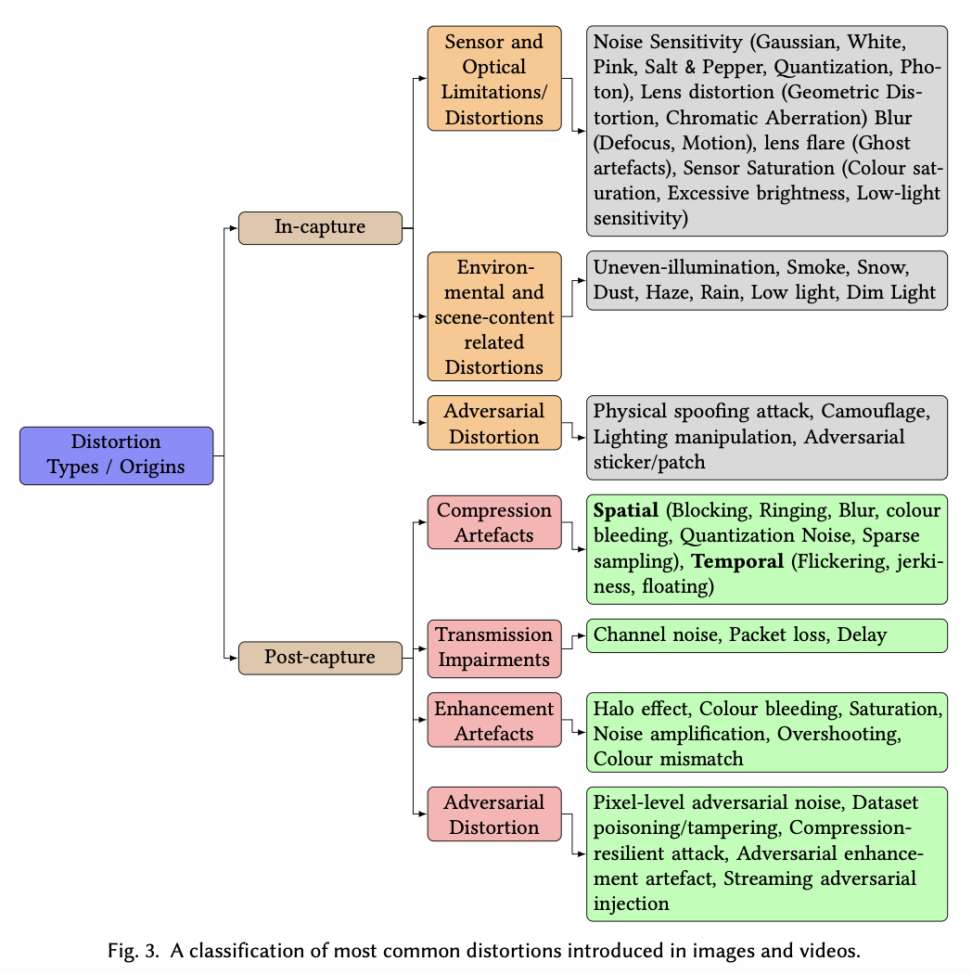
Definition: “Any signal that produces a deviation in the visual perception of the image/video from its original expectation is called distortion. But when the original image or video is unavailable, any component of the observed signal presenting a level of visual discomfort or simply annoying effect on the aesthetic visual appearance is considered as a distortion.” (8)
In-Capture distortion (8-13):
- Sensor/Optical Limitations/Distortions: Noise detection method [29, 63, 64]
- Salt and Pepper Noise in videos and images; caised by transmission errors.
Post-Capture Distortions
- Lossy Compression Artefacts
- Visual Content Quality Enhancement Side Effects (14): Halo effect, color bleeding, saturation, noise amplification, overshooting, colour mismatch…
Adversarial Perturbations in distortion (16):
- In AI-driven systems, adversarial perturbations could result in mistakes. For example, in medical detection or driving scenarios, and in models like R-CNN, modifications on the image/video matrix may result in misidentification.

Distortion Classification
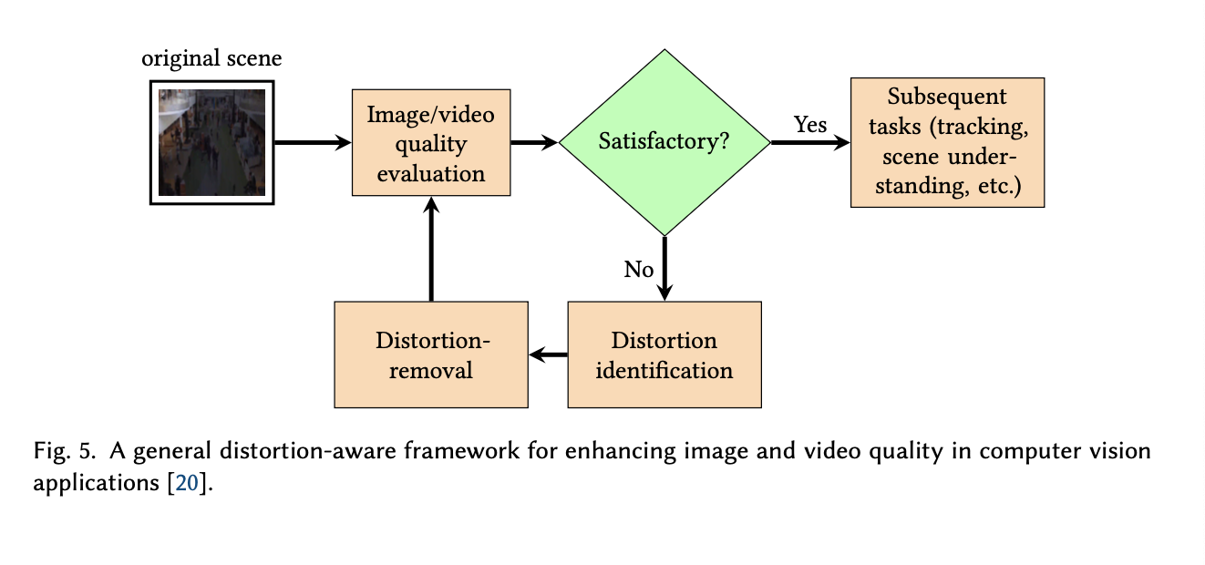
Video Quality Assessment: identify distortion and then estimate quality
[119]: Image blur detection at edges by pooling the Cumulative Probability of Blur Detection (CPBD): an algorithm working through edges -> uses Just Noticeable Width (JNW) to calculate the probability of blur; serves as a blur severity metric. (17)
Methods in Distortion Detection (19)
- Deep CNN specified in distortion classification
- Feature pool: relating metrics and features with possible distortions
- Natural Scene Statistics (NSS)
- Image Quality Metric (IQM): after distortion detection, apply distortion-specified metric on image quality evaluation
- SVM probability + KNN for combining IQMs
Full Reference Approach:
- With access to the pristine image, then applies Gabor filters on both images; then find MSE
- Quadratic Bayes normal classifier -> useful when multiple distortion types present
Video Distortion Classification (19-20)
- Traditional method
Blur → Perceptual Blur Index, or PBI
Smoke → SAN classifier
Noise → Fast noise variance estimator
Uneven illumination → luminance statistics
- ResNet[10]
  - ResNet50 + CNN-LSTM
  - ResNEt50 CNN [9]
- Transformer-based learning in Video Surveillance; VSQuAD dataset [7, 24] (21)
- Methods: Deep learning, temporal models, multitask learning
- Challenges: multiple simultaneous distortion in the same video
Datasets (20-25)
Single Distortion:
LIVE → 808 images, 5 distortion types, 5 levels
TID2008 → 1,725 images, 17 distortion types, 4 levels
TID2013 → 3,025 images, 24 distortion types, 5 levels
CSIQ → 896 images, 6 distortion types, 4–5 levels
Waterloo → 99,624 images, 4 distortion types, 5 levels
KADID-10K → 10,206 images, 25 distortion types, 5 levels

Multiple Distortion:
LIVEMD → multiple distortions such as Blur + JPEG and Blur + WGN
MDID → multiple distorted images with 5 distortion types and 4 severity levels

Domain Focused:
SIDQ → surveillance image quality dataset
LVQ → laparoscopic video quality dataset
VSQuAD → video surveillance quality assessment dataset
CD-COCO → COCO-based dataset with realistic depth-aware distortions
QVCED → video dataset for uneven illumination / enhancement-related distortion
Challenges
- Weak performance on multiple distortions scenarios
- Lacking multi-distortion datasets; natural distortions are rarely addressed
- Global and high-level features should be used in distortion classification

